|  |  |  |
| --- | --- | --- |
| A black background with blue and grey text  Description automatically generatedModule Code: PUSL2022 | Module Name: Introduction To IOT | |
| Coursework Title: Final Project Report | | |
| Deadline Date: 20 April 2024 | | Member of staff responsible for coursework:  Mr. Isuru Sri Bandara Nishshanka |
| Programme: BSc (Hons) Computer Security and BSc (Hons) Computer Networks | | |
| Group Details:    Group X   |  |  |  | | --- | --- | --- | | **PU Index Number** | **Name** | **Role** | | 10899225 | K.A.S.A.Kahandawa | Group Leader and Data Analysing | | 10899366 | A.M.S.D.Senevirathne | Backend, Requirement gathering, Report writing | | 10899381 | W.M.U.N. Wickramasinghe | Testing, Interface, Report writing | | 10899202 | K.U.D.L.Darshana | Hardware development | | 10899377 | A.A.Udaraka | Testing, Report writing, Planning | | 10898677 | B.A.Ranamuka | Planning, Backend, Report writing |   ***We confirm that we have read and understood the Plymouth University regulations relating to Assessment Offences and that we are aware of the possible penalties for any breach of these regulations. We confirm that this is the independent work of the group.*** | | |
| Use of translation software  We have not used translation software. | | |
| **Overall mark _____% Assessors Initials ______ Date_________** | | |

**Smart Dehydration System**

by

Group X

A Project Report

University of Plymouth

March 2024

**Acknowledgements**

We would like to express our sincere gratitude to everyone who helped us finish this report successfully. This project would not have been feasible without their steadfast assistance, commitment, and knowledge.

First and foremost, we would like to sincerely thank our distinguished lecturers for their important mentorship and advice throughout this project. Their wise criticism and inspiring words have kept us moving forward and guaranteed the standard and honesty of our work.

We also thank the other members of the group, whose cooperation and team spirit have been invaluable during the entire project. Each participant enhanced the project and created a lively work atmosphere by bringing their distinct viewpoints, abilities, and passion to the table.

In addition, we would like to thank everyone who contributed resources and help—technical, logistical, or moral. Their assistance has been crucial to helping us overcome obstacles and accomplish our objectives.

Lastly, we express our gratitude to our friends and family for their support during this project, understanding, and patience. Their assistance gave us the platform to pursue our goals in education and the workplace.

Finally, we would like to express our sincere gratitude to everyone who helped make this project possible, no matter how modest the contribution.

**Abstract**

This project develops and evaluates the Smart Dehydration Machine in an effort to solve the problem of effective food preservation. The issue stems from the shortcomings of conventional dehydration techniques, which frequently lead to inconsistent outcomes and food waste. This project's particular goals were to develop a dehydrator that uses Internet of Things technology, analyze how well it preserves food, and determine whether it could have an effect on current food preservation methods. To monitor temperature, humidity, and airflow during the dehydration process, IoT sensors were integrated into the design and implementation of the Smart Dehydration Machine. The accuracy and consistency of the machine were assessed by statistical analysis of the data collected from these sensors.  
Important findings show that the Smart Dehydration Machine successfully keeps food preservation conditions at their ideal levels, leading to consistent drying and flavour and nutritional content retention. User reviews also emphasized the machine's dependability and simplicity of use. With its useful solutions for nutrition and food waste reduction, the Smart Dehydration Machine is a noteworthy development in food preservation technology. The emphasis on a particular machine model and dependence on user feedback are limitations. To improve the machine's usability and accessibility, more study into automation, network expansion, and voice command integration are suggested.

Table of Contents

Introduction 6

Literature review 7

Methodology 8

Key Components 9

Work Breakdown 10

TimeLine 10

Dehydration System Photos 11

Results & Discussion 13

Results 13

Conclusion and Future Works 14

Reference list 15

# Introduction

Food preservation is a major difficulty in the fast-paced world of today. Conventional dehydration techniques frequently fall short, producing erratic outcomes and even wasting resources. Nevertheless, a viable remedy has surfaced: the Smart Dehydration Machine. This ground-breaking invention, which combines cutting-edge technology with intuitive features, promises to completely transform the way that fruits, vegetables, and perishables are preserved.

The objective of this research is to demonstrate how the Smart Dehydration Machine may solve the drawbacks of conventional dehydration techniques. It looks at how this invention meets the needs of food business professionals as well as consumers at home by providing a dependable and effective method of preserving food without sacrificing its flavour or nutritional value.

The importance of innovative techniques for food preservation is highlighted by recent studies, especially in view of the rising concerns regarding nutrition and food waste. In order to solve these issues, the Smart Dehydration Machine stands out as a state-of-the-art method that offers uniformity and accuracy in the dehydration procedure.

Some of the questions we encountered when researching dehydration included:

1. How does the Smart Dehydration Machine compare to conventional dehydration techniques?
2. What advantages does this machine offer to experts in the food sector as well as those utilizing it at home?
3. In what ways does the Smart Dehydration Machine help address issues with nutrition, waste reduction, and food preservation?

The Smart Dehydration Machine's characteristics and advantages will be covered in more detail in the remaining sections of this document. It will examine its layout, capabilities, and uses, offering insights into how this breakthrough can revolutionize food preservation for future generations.

# Literature review

**Overview Of Existing Research**

Numerous investigations have examined traditional dehydration techniques, exposing a range of approaches from sun drying to more advanced procedures including vacuum and freeze-drying.  
  
Traditional dehydration can be energy-intensive and may not always produce consistent quality, especially when dealing with sensitive food items, as research has repeatedly demonstrated.

**Critical Evaluation**

Conventional procedures have a long history of use, are widely accepted, and are easily accessible. This has led to a substantial body of knowledge regarding their advantages and disadvantages.  
  
These techniques can be energy-inefficient and frequently lead to substantial nutrient loss as well as changed textures and flavors. The development of techniques that can maintain quality while being energy efficient is noticeably lacking.

**Addressing Knowledge gaps**

A method that promises efficiency and consistency is introduced by the Smart Dehydration Machine, which could potentially bridge the gap created by traditional approaches.  
  
The system offers a revolutionary way to monitor and modify dehydration parameters in real-time by incorporating IoT technology, which has the potential to completely transform the process.  
  
It tackles the problem of uneven quality in dehydrated goods and suggests a way to use less energy.  
  
By utilizing data analytics, the device optimizes the dehydration process based on new data, improving our knowledge of food preservation.

Systems theory which examines the interconnection of complex systems is the theoretical foundation of the Smart Dehydration Machine and provides a suitable framework for Internet of Things applications.

The research pushes the limits of what is feasible in food preservation and encourages debate of the theory of smart systems in food technology.

# Methodology

The methodology employed for the Smart Dehydration Machine project involved a systematic approach to data collection and analysis, utilizing a combination of techniques, tools, and materials tailored to IoT-based research in food preservation. The dehydration machine's IoT sensors were the main tool used for data collecting. These sensors kept an eye on important dehydration-related metrics like temperature, humidity, and airflow. A central data collecting system was linked to these sensors, enabling data logging and monitoring in real time.

Statistical methods and data visualization software were used to examine the gathered information to spot trends and patterns in the dehydration process. Furthermore, qualitative analysis methods were used to analyse user comments and determine how well the machine performed overall in accomplishing its goals.

The integration of IoT technology into the dehydration machine and guaranteeing smooth connectivity between sensors and the data collecting system were the main challenges faced during the research. These difficulties were resolved by carefully calibrating and testing the sensors and by resolving connectivity problems.

The approach's overall efficiency was assessed by looking at how well it met the project's goals, which included food preservation accuracy and consistency, user-friendliness, and tackling issues with nutrition, waste management, and food preservation. The implementation of innovative IoT-based techniques was supported by their capacity to offer data-driven insights and real-time monitoring during the dehydration process, hence augmenting the dependability and effectiveness of food preservation methods.

# Purpose

Our intelligent dehydration device offers exact control and automation, revolutionizing fruit preservation. It guarantees ideal dehydration conditions by combining heating elements, blowers, load cell, humidity, and temperature sensors. The manual and auto modes accommodate varying user preferences. Users can enter custom temperature and time settings in manual mode, providing flexibility for unique dehydration procedures. Simultaneously, the auto mode simplifies the user experience by optimizing the operation through autonomous parameter adjustments based on load weight and environmental factors. By extending the shelf life of fruits without sacrificing their flavor or nutritional value, this cutting-edge gadget enables consumers to easily enjoy homemade snacks free of preservatives. Whether used by small-scale producers, health-conscious people, or food enthusiasts, our clever dehydration machine provides a practical and effective way to preserve fruits all year long.

# Benefits

1. Efficient Dehydration Process: The machine optimizes the dehydration process by using temperature, humidity, and load cell sensors. It guarantees uniform and complete fruit drying, increasing productivity over more labor-intensive traditional methods that call for human oversight.
2. Customized Dehydration: Users can input precise temperature and time settings according to their preferences or the needs of various fruits by using the manual mode option. Better-quality dried fruits are produced because of this customization, which gives exact control over the dehydration process.
3. Time-saving Automation: When the machine is in auto mode, it automatically modifies the dehydration process according to the fruit's weight input. Users save time and effort by not having to manually check the process or determine how long it will take for various amounts of fruits.
4. Consistent Outcomes: Every usage is guaranteed by the integration of sensors. Users can anticipate consistent drying of all fruits whether in manual or auto mode, doing away with the possibility of under- or over-drying that comes with manual dehydration techniques.
5. Energy Efficiency: The device maximizes energy use for the dehydration process by dispersing heat using blowers and a heater. This is an environmentally friendly option because it not only uses less energy but also lowers operating costs over time.
6. User-Friendly Interface: Regardless of user experience level, the machine's interface makes dehydration easier. Users can effortlessly switch between manual and auto modes with the help of clear instructions and intuitive controls, guaranteeing a flawless experience from beginning to end.

# Key Components

* The project's smooth integration of an ESP32 Module and Arduino board creates a strong connection via wired serial communication, enabling convenient Wi-Fi connectivity through a web server interface.
* All project components-sensors, actuators, and relays are effectively interfaced with the Arduino board through the use of a painstakingly crafted custom circuit board, guaranteeing a streamlined and small system architecture.
* The DHT sensor, a vital part of the system, provides precise temperature and humidity readings and is essential to data acquisition. Future maintenance analysis and optimization efforts will be built upon this data.
* The project gains additional functionality with the addition of a load cell sensor, which makes it possible to precisely measure the weight of the fruits or vegetables that are added to the dehydration process. This information is crucial for adjusting the dehydration period and guaranteeing the best outcomes.
* Two essential components of the dehydration process are an AC current blower fan and a powerful 500W heater, which are carefully chosen to offer enough heat and airflow to effectively dehydrate food.
* The project uses three relay modules to control airflow and optimize dehydration conditions. These modules enable the fan speeds to be adjusted across Low, High, and Mid settings, ensuring effective air circulation throughout the dehydrator.
* To further improve functionality, a servo motor is used to control the release of moisture and pressure both during and after the dehydration process, making it easier to maintain the optimal dehydration conditions.
* In order to ensure safe and dependable operation throughout the dehydration process, the project incorporates a Solid State Relay (SSR) system and uses a dependable 12V power supply. This ensures the longevity and protection of system components.

# Work Breakdown

**Smart Dehydration**

**System**

# TimeLine

# Dehydration System Photos

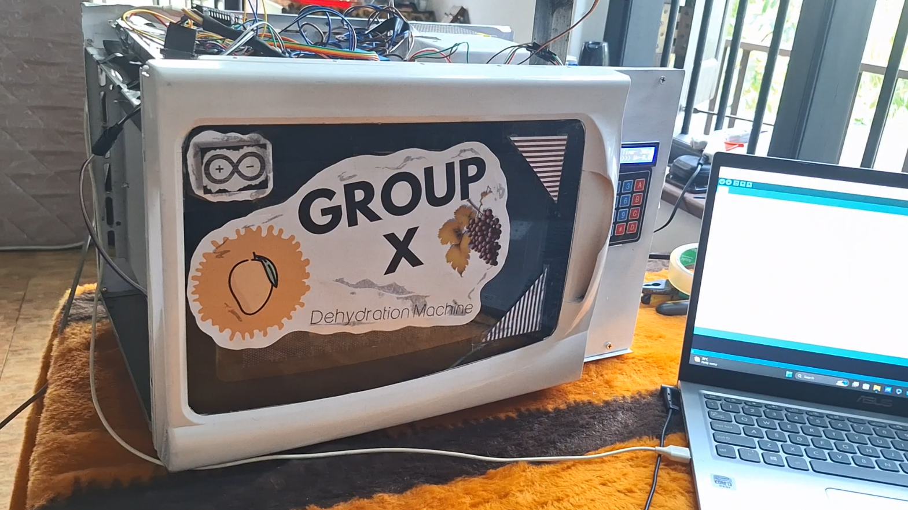

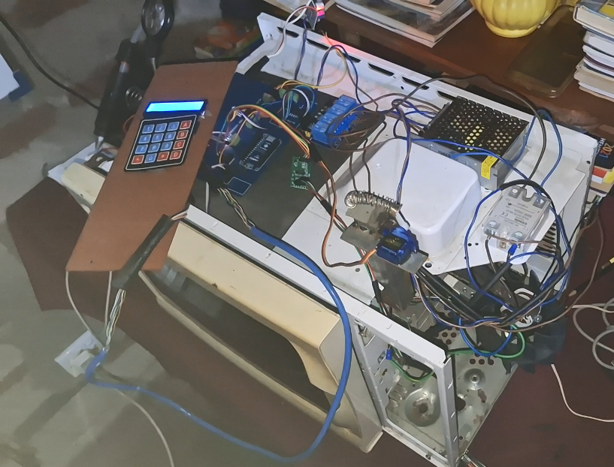

* Dehydration Before and After

* Dehydration Data Analysis

# Results & Discussion

# Results

The results of the study show that the Smart Dehydration Machine successfully keeps the dehydration process consistent and precise. IoT sensor data showed consistent humidity and temperature throughout the dehydration cycle. User reviews also emphasized how user-friendly and dependable the device is at retaining the flavor and nutritional value of a variety of foods.

**Discussion**

The temperature and humidity levels that are consistently monitored throughout the dehydration process indicate that the Smart Dehydration Machine effectively tackles issues related to conventional methods, which frequently lead to uneven drying and possible food waste. The machine guarantees consistent results and reduces the possibility of over- or under-drying by keeping ideal conditions.

Positive user reviews also highlight how useful the equipment is for both professionals in the food sector and average consumers. Its features that are easy to use allow people with different skill levels to utilize it, and its dependability gives users trust in its ability to maintain food quality.

The results imply that, in the larger framework of food preservation, the Smart Dehydration Machine helps to address important issues with nutrition and food waste reduction. Fruits, vegetables, and other perishables can be preserved with a high degree of dependability and efficiency, which reduces food deterioration and increases shelf life. Moreover, it encourages better eating practices and raises customer satisfaction by maintaining the flavour and nutritional value of preserved foods.

All things considered, the results highlight how important the Smart Dehydration Machine is as a revolutionary approach to the complicated problems associated with food preservation in the modern world. Its precision, uniformity, and nutritional content retention make it an invaluable tool for people and organizations looking for effective and environmentally friendly food preservation techniques.

# Conclusion and Future Works

Insights into the field of food preservation have been gained from the research of the Smart Dehydration Machine, especially when considering IoT-based technology. Important results show that the device provides accuracy, consistency, and dependability in the preservation process while successfully addressing issues related to conventional dehydration techniques. The system has proven its ability to maintain the flavour and nutritional value of different food items by measuring temperature and humidity levels in real-time and gathering input from users.

The implications of these findings are significant, both practically and theoretically. The Smart Dehydration Machine offers a tangible solution to pressing challenges in food waste reduction and nutrition by providing a reliable means of preserving food, benefiting consumers and businesses alike. Moreover, the study advances the understanding of food preservation by demonstrating the potential of IoT-based technologies to enhance traditional methods. Integration of IoT sensors not only improves precision and consistency but also paves the way for further innovation and research in the field.

This study has limitations despite its contributions. Because of its narrow emphasis, results may not apply to other models or brands of dehydration machines. Furthermore, depending solely on user input and sensor data may not adequately account for all the variables affecting the machine's performance in practical situations. However, the Smart Dehydration Machine is a promising development in food preservation that addresses modern issues. Although more investigation is necessary to fully realize its potential and address its drawbacks, this work lays the groundwork for further developments in the area.

Prospective investigations may focus on augmenting the automation functionalities of the Smart Dehydration Machine, investigating strategies to optimize and mechanize many facets of the dehydration procedure. Furthermore, network growth could allow for the remote monitoring and management of several dehydration units, which would let larger businesses scale and operate more effectively. Another intriguing direction for future development is the integration of voice command technology, which will give customers simple, hands-free control over the dehydration process. All things considered, these developments could lead to even greater functionality, usability, and food preservation efficacy from the Smart Dehydration Machine.

# Reference list

# 